**OptIT –** An Android App to purchase the products for various needs

V.K.G. Kalaiselvi #1, HEMANTH P #2, DINESH P #3

#1Assistant Professor, #2, #3Student,

#1, #2, #3 Department of Information Technology

#1, #2, #3Sri Sai Ram Engineering College, West Tambaram, Chennai -600044

*[#1](mailto:#1kalaiselvi@sairamtap.edu.in)*[kalaiselvi@sairamtap.edu.in](mailto:#1kalaiselvi@sairamtap.edu.in) , [*#2*sec19it020@sairamtap.edu.in](mailto:#2sec19it020@sairamtap.edu.in) , *#3*sec19it072@sairamtap.edu.in

**Abstract:**

**“It’s really clear that the most precious resource we all have is time.” - Steve Jobs**

**Our application is basically an android application that helps people to order and buy groceries, food, fruits and vegetables, dress, hardware’s. Our main aim is to make the shopping for products that they need in a safe and quick manner from their nearby shops registered in out app by the vendors. Through our app, Customers can order things from their home or office or from anywhere, and can pick their order when they need. From our app, the Vendors can see the orders placed by the customers and pack those things, then a notification will be sent to the customer. The customers can pick their products from the shop just by paying the total amount. With this app, what we gain is safety and the time of standing in the shops for buying things. During the pandemic situation we expect that this app will be more useful for Vendors and the Customers.**

**Keywords: Android Application, Customer, Vendors, Nearby Shops, Safety and Time Saving.**

**INTRODUCTION**

In recent years, there has been a growing demand for organic produce as consumers become more aware of the health and environmental benefits of organic farming. However, many customers face challenges in accessing organic produce due to limited availability and lack of information.

To address these challenges, we present an application for organic farming that connects vendors and customers through a user-friendly interface. Our application leverages the power of technology to provide customers with a comprehensive platform for purchasing organic produce directly from local farmers and vendors.

Through our application, vendors can create profiles and showcase their products, while customers can search for products based on location, availability, and product type. The application also features a payment system that enables customers to make secure transactions with vendors, ensuring a seamless and hassle-free buying experience.

In addition to facilitating transactions, our application also provides customers with information on the benefits of organic farming and the importance of supporting local farmers. By raising awareness and promoting sustainable farming practices, our application aims to create a more connected and environmentally-conscious community.

In this IEEE paper, we provide a detailed overview of the technical aspects of our application and present the results of our user testing, demonstrating the effectiveness of our approach in promoting organic farming and supporting local communities.

**PROPOSED SYSTEM**

The proposed system for our organic farming application connecting vendors and customers is a comprehensive platform that enables vendors to showcase their products and customers to purchase organic produce directly from local farmers and vendors.

Our system comprises several key components, including:

1. **Vendor Profiles:** Vendors can create profiles on the platform, including information on their farm, products, and availability. This information is displayed to customers, enabling them to easily search for and identify vendors that meet their needs.
2. **Product Catalogue:** Vendors can upload product information and images, which are displayed in a searchable catalog for customers to browse. Customers can search for products based on location, availability, and product type.
3. **Ordering and Payment System:** The system features a secure ordering and payment system that enables customers to purchase products directly from vendors. Customers can make payments using a variety of payment methods, including credit card, PayPal, and other secure payment systems.
4. **Delivery and Pickup Options:** Customers can choose to have their products delivered or pick them up directly from the vendor. Vendors can set their own delivery and pickup options, enabling them to customize their services to meet their customers' needs.
5. **Information and Education:** The platform also features information on the benefits of organic farming, the importance of supporting local farmers, and tips for sustainable living. This information is designed to educate and engage customers, promoting the values of organic farming and sustainability.

Our proposed system is built using modern web technologies and Android Studio, including XML and Java. The system also uses a cloud-based database (Firebase Realtime database) to store and manage data, ensuring scalability and reliability.

In this IEEE paper, we will provide a detailed overview of the technical components of our system, including architecture, implementation, and testing. We will also present the results of our user testing, demonstrating the effectiveness of our approach in promoting organic farming and supporting local communities.

**SYSTEM ARCHITECTURE**

The system architecture consists of implementing the Customer and Shop Owner corner individually. The data’s entered by the Customer and the Shop Owner are stored in the Firebase Database. The components with their purpose can be explained as below.

**A. User Information:**In this component, the User has to Login if they have already Signed up. Else, they have to Sign Up into the app as a new User. If the user is a customer, their name, phone number, password is to be entered to create their new Customer account. If the user is a Shop Owner, their Shop Name, Shop Address, phone number and password are to be entered to create their new Shop account. The entered details are saved in the Database.

**B. Product Details:** In this component, the Shop Owner can add the products available in their shop. The product details such as product name, availability, price, image will be updated by the Shop Owner. These details will be stored in the Database from the Shop Owner’s side. The Customer can select their preferable shop and can view the product details which are stored in the Database by the respective Shop Owner.

**C. Order & Delivery:**In this component, the Customer can select the products from their chosen shops and add them to the cart. From the cart, they can view the waiting time (i.e., the time taken for delivery), according to the waiting time, the customer can either place or cancel the order. If they cancel the order means, they can select another shop and place the order. After placing the order, the Shop Owner can view orders from the various customers and can pack the orders accordingly. After packing they can notify the customer and the customer can pay and pick their orders from the respective shops.

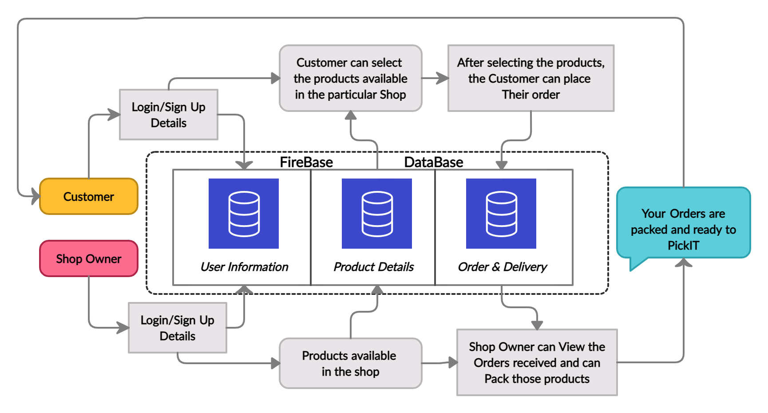

***Figure 3. System Architecture Diagram***

**WORKING**

Once the application is downloaded and installed in your mobile phone, it will ask whether the installed person is a Customer or a Shop Owner as shown in ***Figure 4***. If the person is a Customer, it will be redirected to the Customer Login page as shown in ***Figure 5***. If the person doesn’t have a login, they have to Signup and then Login. If the installed person is a Shop Owner, it will be redirected to the Shop Owner’s Login Page as shown in ***Figure 5***. If the person doesn’t have a Login they have to Signup and then Login.

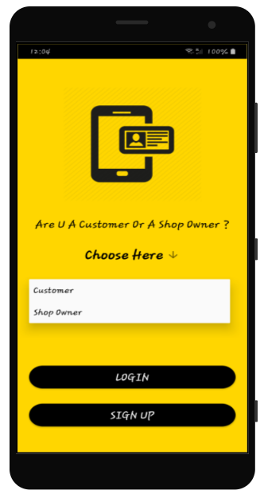 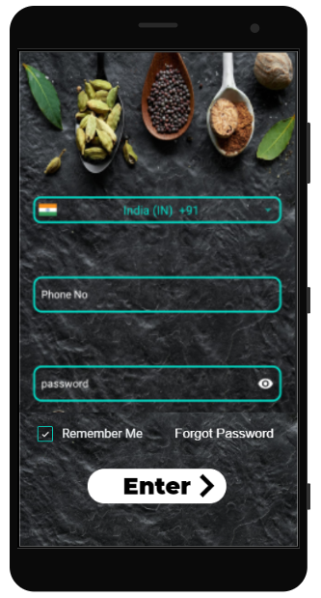***Figure 4: Login selection page Figure 5: Login Page***

***Customer Page:*** Now, in the Customer’s page they should choose their shop, then the products available in the shops will be listed in the Customer’s Home page as shown in ***Figure 6***.

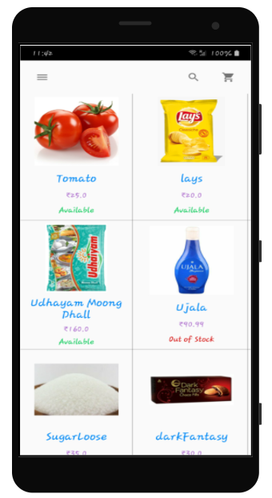 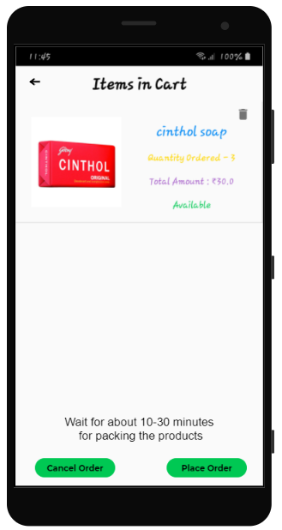

***Figure 6: Customer Home Screen Figure 7: Customer Cart***

They can select the products which are available in that shop. Now the waiting time to receive their order will be displayed to the Customer before placing the order as shown in ***Figure 7***. According to the waiting time they can place or cancel the order. If the customer cancels the order in that shop, they can choose another shop and can order their products.

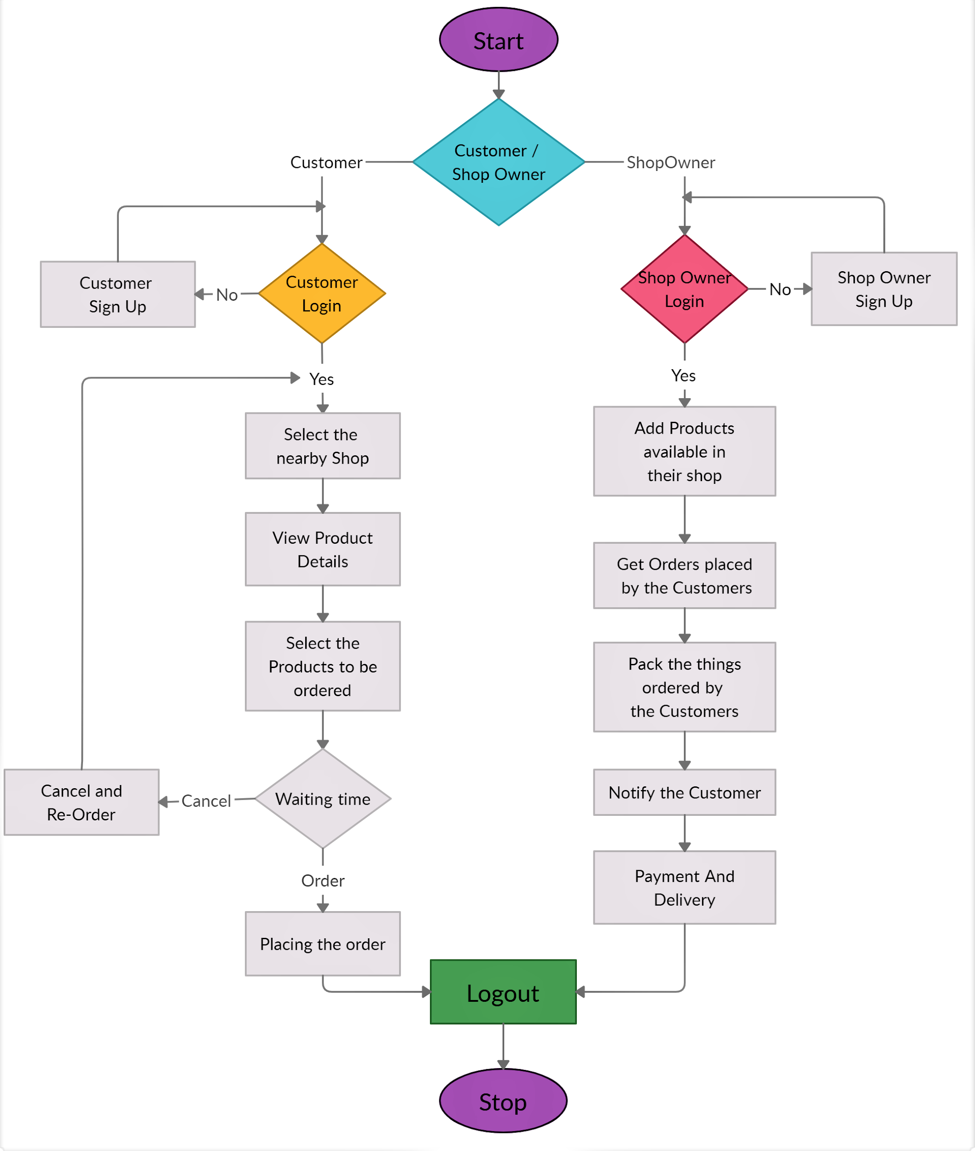

***Figure: Flowchart of OptIT***

***Shop Owner Page***: Simultaneously in the Shop Owner’s Home page, they can add the products available in their shop as shown in ***Figure 9***. If the product is not available in their shop means, they can make it as Out of Stock as shown in ***Figure 8***. The Shop Owner can also update the price of the available products accordingly. The Shop Owner has the Orders page, where they can see the orders received from various Customers as shown in ***Figure 10***. According to the orders, the Shop Owner can pack the things and make it ready for delivery as shown in ***Figure 11.***

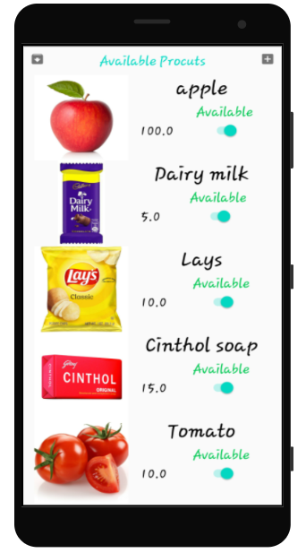 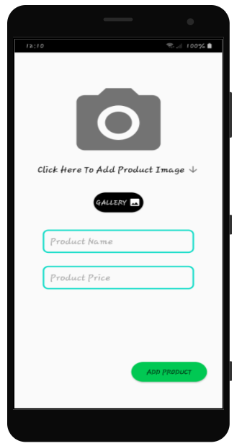

***Figure 8: Shop Owner Home Screen Figure 9: Add Products Page***

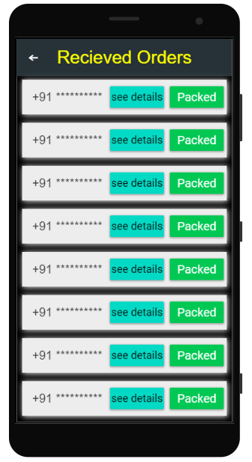 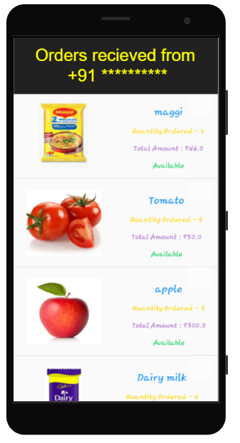

***Figure 10: Received Orders Figure 11: Order Details***

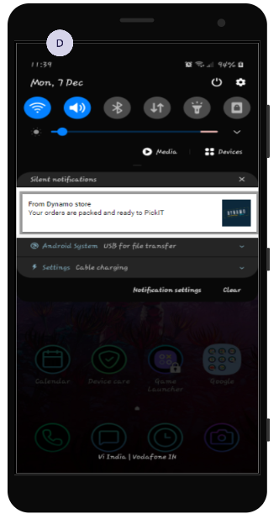

***Figure 12: Notification send to the Customer***

After packing the products ordered by the Customer, the Shop Owner will send a “Your Order is Ready to Pick” notification to the customer as shown in ***Figure 12.***

By seeing the notification, the Customer will come to the shop and can pay the money to the Shop Owner and Pick their products.

**ORGANIC FOOD AND HEALTH SURVEY**

Several studies have suggested that consuming organic produce may have health benefits compared to conventionally-grown produce. For example, a review of 343 studies found that organic crops had higher levels of antioxidants and lower levels of pesticide residues compared to conventionally-grown crops (Baranski et al., 2014).

There have been several studies and surveys conducted in India that have explored the relationship between organic farming and health. Here are some examples:

1. A study conducted in 2017 found that farmers who practiced organic farming in India had better health outcomes compared to those who used conventional farming practices. The study found that organic farmers had lower rates of respiratory diseases, skin disorders, and eye problems compared to conventional farmers (Singh et al., 2017).
2. Another study conducted in India in 2018 found that consumers who purchased organic produce had better health outcomes compared to those who consumed conventionally-grown produce. The study found that consumers of organic produce had lower rates of chronic diseases such as diabetes and hypertension (Pawar et al., 2018).
3. Another study conducted in France found that people who consumed organic food had lower rates of cancer compared to those who consumed conventional food (Baudry et al., 2018). However, it should be noted that this study had limitations, and more research is needed to fully understand the relationship between organic farming and cancer risk.
4. In terms of surveys, a 2019 study conducted in the United States found that 81% of consumers believed that organic produce was healthier than conventionally-grown produce (Liu et al., 2019). The same study also found that consumers were willing to pay more for organic produce, indicating a growing interest in organic farming and its potential health benefits.

Overall, while more research is needed to fully understand the health benefits of organic farming, existing studies and surveys suggest that there may be some benefits associated with consuming organic produce.

**FUTURE IMPLEMENTATION**

In the future, our organic farming food and homemade products app can be expanded and enhanced with several key features to improve its functionality and value to users. Some potential future implementations for our app for IEEE are:

1. **Recipe Sharing:** Adding a feature that allows users to share their favorite recipes using organic produce and homemade products. This would encourage users to try new recipes and increase the usage of organic produce and homemade products in cooking.
2. **Community Building:** Adding a community feature that connects users with similar interests in organic farming, homemade products, and healthy living. This would enable users to share ideas, ask questions, and connect with like-minded individuals.
3. **Expanded Product Offerings:** Expanding the range of products offered on the app to include other organic and sustainable products such as cleaning supplies, personal care products, and household items. This would create a one-stop-shop for users to purchase all of their organic and sustainable products.

**COMMERCIAL VIABILITY**

This android application will be effective if used by many organic farmers, homemade products makers and local shop owners, since there is no other android application like this have been implemented so far. This application can also be commercialized. Since our app has easy and simple User Interface (UI), it can also be used by the person who is even first to use this application.

**CONCLUSION**

In conclusion, our organic farming food and homemade products app has the potential to make a significant impact in the organic farming and sustainable living space. By providing a platform for consumers to purchase organic produce and homemade products directly from local vendors, our app can support small-scale farmers and promote sustainable farming practices.

With future implementations such as recipe sharing, community building, expanded product offerings, and customizable subscriptions, we can enhance the functionality of our app and provide users with a comprehensive resource for organic and sustainable living.

**REFERENCE**

**[1] Usha Kiruthika, S. Kanaga Suba Raja, V. Balaji, C.J. Raman, E-AGRICULTURE FOR DIRECT MARKETING OF FOOD CROPS USING CHATBOTS ,2020 International Conference on Power, Energy, Control and Transmission Systems (ICPECTS), Electronic ISBN:978-1-7281-1084-4**

**[2] Phan Hong Hai, Bui Thanh Khoa , Organic foods online shopping intention: The moderator role of Social Distancing policy, 2021 International Conference on Data Analytics for Business and Industry (ICDABI), Electronic ISBN:978-1-6654-1656-6**

**[3]Sowmyaa V. R, Karthika. A, Shivani. B, T. Sheela, Cloud Based E-Commerce Application For Organic Fertilizers, Pesticides And Other Products And Crop Disease Identification Using Computer Vision, Electronic ISSN: 2329-7190**

s